SmartSDLC – AI-Enhanced Software Development Lifecycle

# 1. Introduction

• Project title : SmartSDLC – AI-Enhanced Software Development Lifecycle

• Team leader : yoga S

• Team member : gayathri S

• Team member : anusuya L

• Team ID: NM2025TMID08069

# 2. Project Overview

• Purpose :

SmartSDLC uses the Granite model from Hugging Face to speed up software development. It lets users upload PDFs, generate clear requirements, turn prompts into code, create tests, fix bugs, write docs, and chat with an AI helper. The project is deployed in Google Colab using Granite for easy setup and reliable performance.

• Features:

Requirements Generation  
 Code Generation  
 Automated Testing  
 Bug Fixing  
 Documentation Creation  
 AI-powered Chat Assistance

# 3. Architecture

Frontend (Gradio):  
The frontend is built with Gradio, providing an interface for requirement input, code generation, and bug fixing.

Backend (Google Colab + IBM Granite):  
Google Colab provides the execution environment. IBM Granite models from Hugging Face are used for requirement extraction, natural language processing, and code generation.

# 4. Setup Instructions

Prerequisites:

1. Gradio Framework Knowledge  
2. IBM Granite Models (Hugging Face)  
3. Python Programming Proficiency  
4. Version Control with Git  
5. Google Colab’s T4 GPU Knowledge

Installation Process:

1. Open Google Colab.  
2. Create a new notebook.  
3. Set runtime to T4 GPU.  
4. Install dependencies using '!pip install transformers torch gradio PyPDF2 -q'.  
5. Run the provided SmartSDLC code.  
6. Access the Gradio app via the generated link.

# 5. Folder Structure

project/  
 ├── smart_sdlc.ipynb – Main notebook file  
 ├── requirements.txt – Dependencies  
 ├── README.md – Project documentation  
 └── app/ – Optional additional scripts

# 6. Running the Application

1. Launch the Google Colab notebook.  
2. Run all cells sequentially.  
3. Wait for the model to load.  
4. Click on the Gradio-generated link to access the SmartSDLC app.

# 7. API Documentation

The SmartSDLC application uses Gradio endpoints for interaction. Example endpoints include:  
• /generate_requirements – Generates requirements from uploaded PDFs  
• /generate_code – Converts prompts into code  
• /fix_bugs – Suggests fixes for code  
• /generate_tests – Creates test cases  
• /generate_docs – Generates documentation

# 8. Authentication

Currently, the application is deployed in an open environment. For secure deployment:  
• API keys for IBM Granite  
• OAuth2 authentication for user access  
• Role-based access (admin, developer, tester)

# 9. User Interface

The interface is built with Gradio. It provides:  
• Requirement input forms  
• Code generation panels  
• Bug fixing modules  
• Testing and documentation views

# 10. Testing

Testing includes:  
• Unit Testing: For requirement parsing, code generation.  
• API Testing: Using Gradio endpoints.  
• Manual Testing: Running notebook cells and verifying results.  
• Edge Cases: Invalid inputs, corrupted PDFs.

# 11. Screenshots

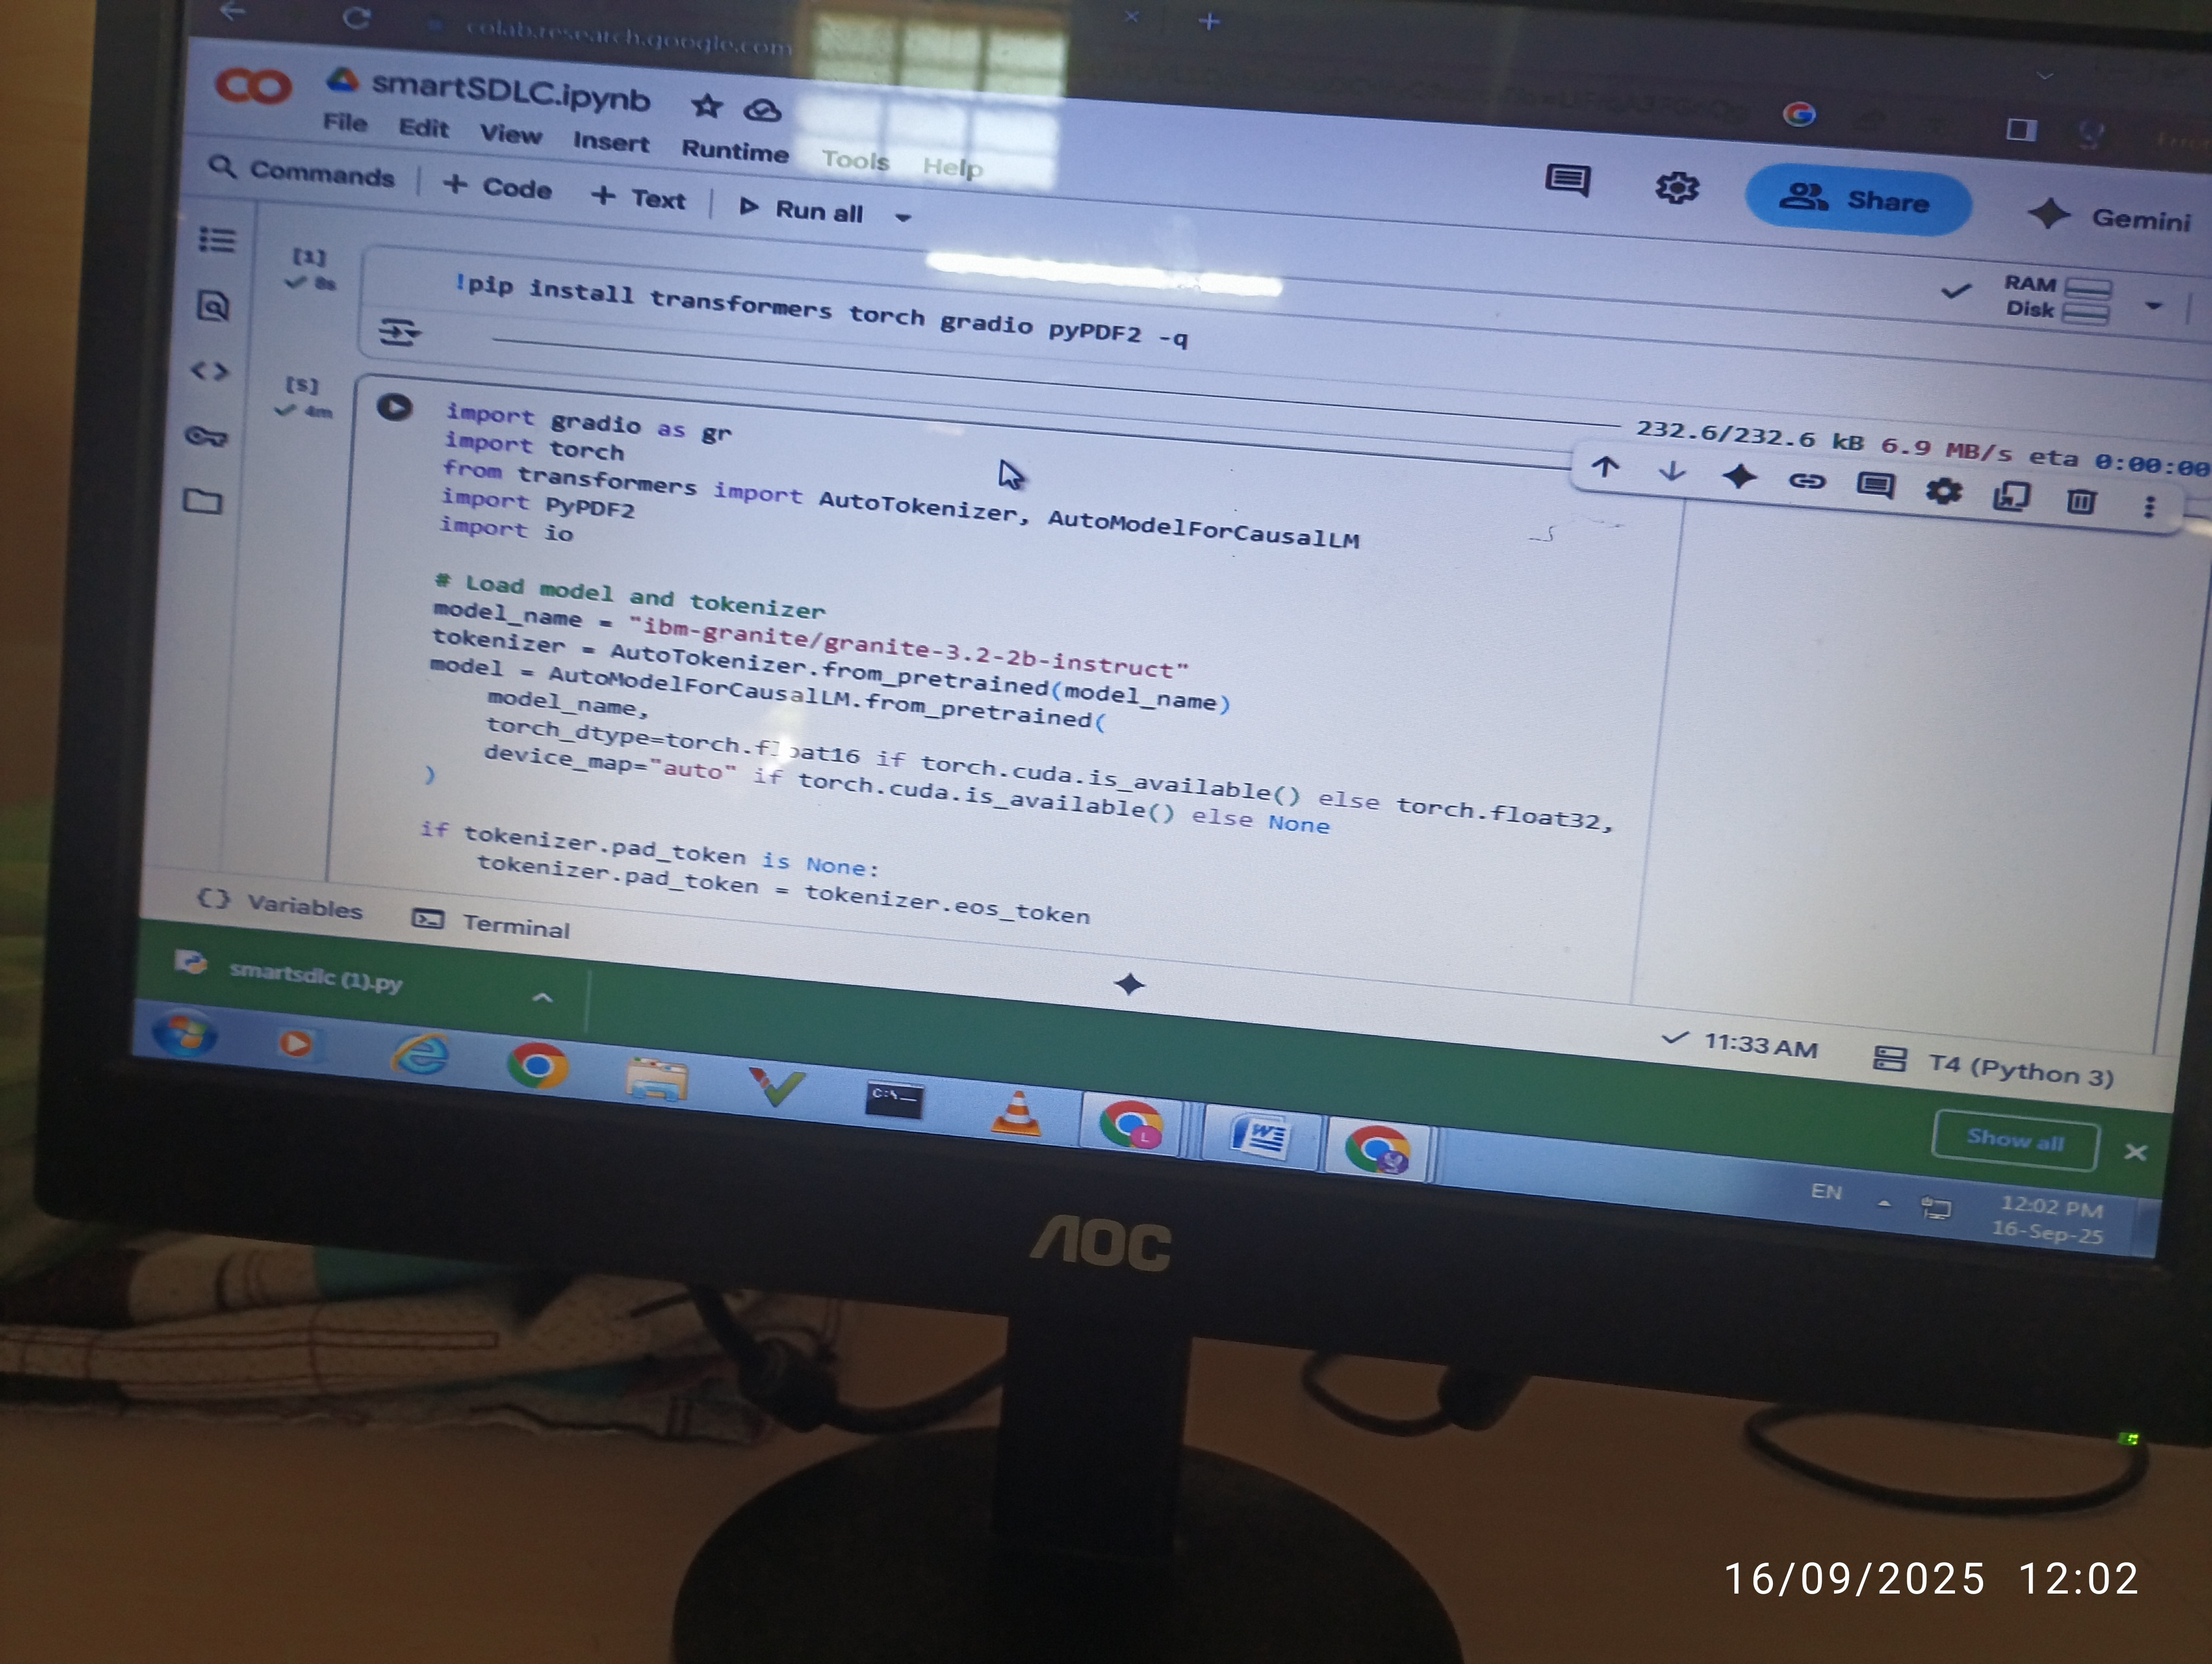

# 1758004740225.jpg

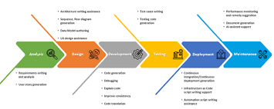

# 12. Known Issues

• Limited handling of complex software requirements.  
• Accuracy of bug fixes depends on model capabilities.  
• Requires internet for model access from Hugging Face.

# 13. Future Enhancement

• Support for larger projects and multiple modules.  
• Integration with CI/CD pipelines.  
• Enhanced test case generation.  
• Improved bug-fixing accuracy.